Running the Race: Resilient Leaders, Resilient Teams

Can we grow more resilient? The good news is that research shows that we can. The best news is that God provides his people with better means to becoming and remaining resilient than the best wisdom the world can offer. In this session, we'll explore what resilience is, discover what contributes to resilience, and then set our understanding of all this within God's story of redemption. We'll walk through practical exercises that will help you recognise and practice ways of developing greater resilience, applying rich biblical truths about God and humanity and the world as we do so. The aim is to help each of us apply these truths both to ourselves and to the people and teams we lead.

Jen Charteris, originally from South Africa, is the executive director of Crosslands, which provides in-context theological training from Foundation to PhD level across the UK, Europe, and beyond. Previously she spent over 25 years working in strategic change, organisational consulting, and board and leadership development. She has been a senior advisor on major change programmes in government, defence, infrastructure, and financial services, taught on various MBA programmes and at the UK Military’s Defence Academy, worked internationally with the leaders of Christian ministry organisations, and has many years of board experience. She is married to Hugo, a church pastor and planter in the north of England, and they have two adult children.

Cultivating resilience
“Resilience is the capacity to deal successfully with the obstacles we encounter whilst maintaining our path towards life’s goals”

Bouncing back from setbacks
Surviving immense pressure
Enduring over time

What is resilience?

Cultivating resilience is even better for believers…

- within the story of redemption
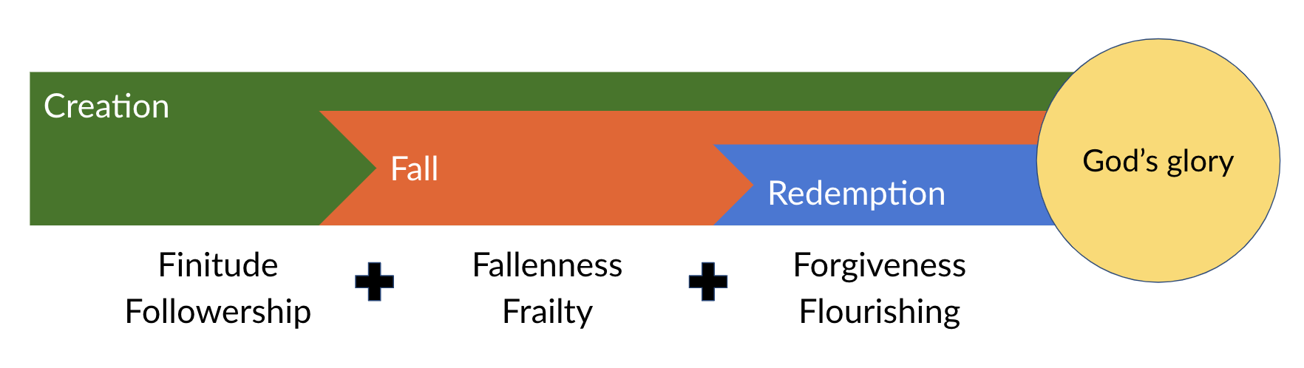




HEAT

Same heat;
Different outcomes

- going ‘with the grain’ of creation and God’s good design

Time, space, language, stories, relationships, objects, habits…

- Thinking about thinking, 3 ways:
purpose, perspective and patterns

  - The foundational importance of purpose

- What really matters to me?  - What am I really striving after?  - What dominates my conversation?  - What do I want my epitaph to be? | - What is the greater goal for which I’m willing to give up short term gains or pleasures?  - What do I spend my time/money/energy on? Why?  - What am I going after in my relationships and work?

Quick-write (4-7 minutes)… in the style of Postcard | Letter to my kids | “Once upon a time...” Newspaper crime report | Letter from my older/younger self etc.

  - The transformative potential of perspective

- “This too shall pass”
- “This is part of my story, but not my identity”
- Things may be broken for now, but not forever
- How will today’s setback look in one, two, five years?
- How would this look to someone from another time or culture?

Read Ecclesiastes. Cultivate diverse friendships. Extend your sources of news.

  - The amazing power of thinking patterns

To what extent do you agree: “I choose what I experience” ?

1 | 5 | 9

“Between stimulus and response there is a space.
In that space is our power to choose our response.
In our response lies our growth and our freedom.”
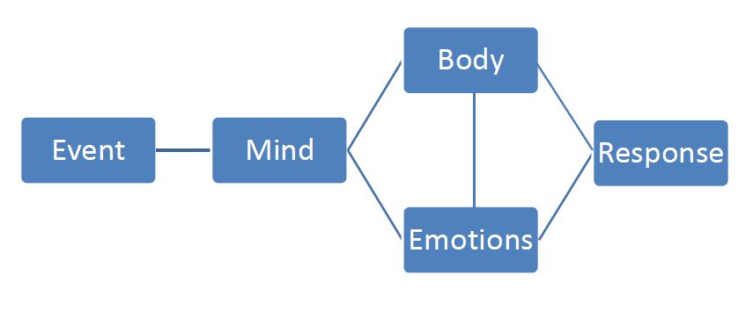
Viktor Frankl

Choice is
HERE!

- Recognise the underlying desire or fear that may be shaping your thoughts, emotions and responses.
‘SCARF’ Threats (Modern-day ‘lions’/idols?):

Status – sense of significance to others
Certainty – ability to predict the future
Autonomy – ability to control events
Relatedness –sense of safety with others
Fairness – perception of fair exchanges

…Fight? Flight? Freeze

- Recognise the eternal truths about God that transform these desires and fears: God is great, good, glorious, gracious and generous!

- Recognise the interaction of beliefs, physiology, emotions and behaviour….
stretch out the space between stimulus and response…and learn to exercise choice.

- Look for your own thinking biases: e.g. Confirmation bias; Faulty attribution error; Catastrophising; Mind-reading, Story-telling, Victim pattern etc.


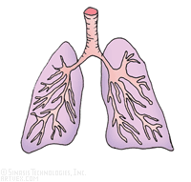
Buying time to think: Breathe!

Establish coherence:
6-8 breaths
per minute

Buying Time to
Think: Breathe!
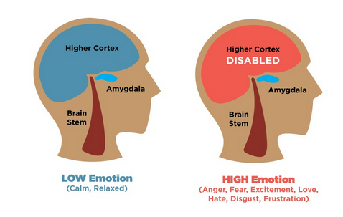

Reflecting on relationships
Relationships are a vital factor in resilience:

- List out and reflect upon your relationships: Close/Enduring/Casual….Giving/Receiving/Enjoying
- How do the boundaries work:
Too closed? Too open? Intentionally permeable?
- How do I manage others’ expectations?
How do I filter the ‘incoming’?


Making microchoices

But what’s it all for?

2 Cor 4:5 – 10 1 Peter 5:6-10

