The Jesus Model: How Simple Principles from the Life of Christ
Can Transform Your Ministry
Since youth culture is a constantly moving target, those who work with young people are often looking for something “new” – and even more so in the time of COVID. What are the latest trends, how do we capture young people’s attention, what will make our programs attractive and contemporary? While there is nothing wrong with being current, the most profound insights about youth ministry are actually very “old”. We forget that Christianity began as a youth movement. Many of Jesus’ disciples were teenagers when he called them. How did his youth group launch a movement that changed the world? If Jesus were to teach us how to lead an effective youth ministry today, what would he say?

Rob Chestnut is the director of training for Josiah Venture, a youth ministry organization serving Central and Eastern Europe. He studied organizational communications at Cedarville University before moving to the Czech Republic in 2003 where he found a passion for working with young people both in Europe and America. He and his wife, Audrey, joined Josiah Venture in 2010 and served in their English camp ministry for 6 years before moving back to America to serve in their home church. He returned to Josiah Venture in 2019 settling in Ostrava, Czech Republic with Audrey and their two young girls. He loves to train up young people to know Jesus more, discuss great stories that unite us, and bring history alive for others to experience.

- What is the purpose of youth ministry

  - To fulfill the Great Commission (Matt 28:18-20)

  - "Then Jesus came to them (the eleven disciples) and said, 'All authority in heaven and on earth has been given to me, Therefore, go and make disciples of all nations; baptizing them in the name of the Father and of the Son and of the Holy Spirit and teaching them to obey everything I have commanded you. And surely I will be with you always, to the very end of the age,"

- Understanding the great commission

  - The great commission only has two command, “verbs”. The other three verbs are in a different form and explain the three things we need to do to fulfill this command.

    - Command verb 1:________________

    - Command verb 2: ________________

    - _________________

      - Take the initiative to make contact with non-believers.

    - ___________________
      - Identify people with the person and work of Jesus Christ.

    - Teach them _________________
      - Equip people to be active in their faith rather than passive, engaged in serving the Lord

    - Your youth ministry exists as God's chosen vehicle for assisting believers in the fulfillment of the great commission.

    - “Within a few years most organizations loose sight of their mission and
become focused on methods - doing things right rather than doing the right things." Peter Drucker

- How did Christ model the great commission?

  - John 20:21 "As the father has sent me, I am sending you."

  - His life serves as the model for our ministry.

  - Christ modeled the process of making a disciple, as well as the process of building a disciple making ministry.

  - The process of making a disciple

    - Christ met people where they were at and challenged them to take the next step forward spiritually. In his life we see five basic types of challenges.

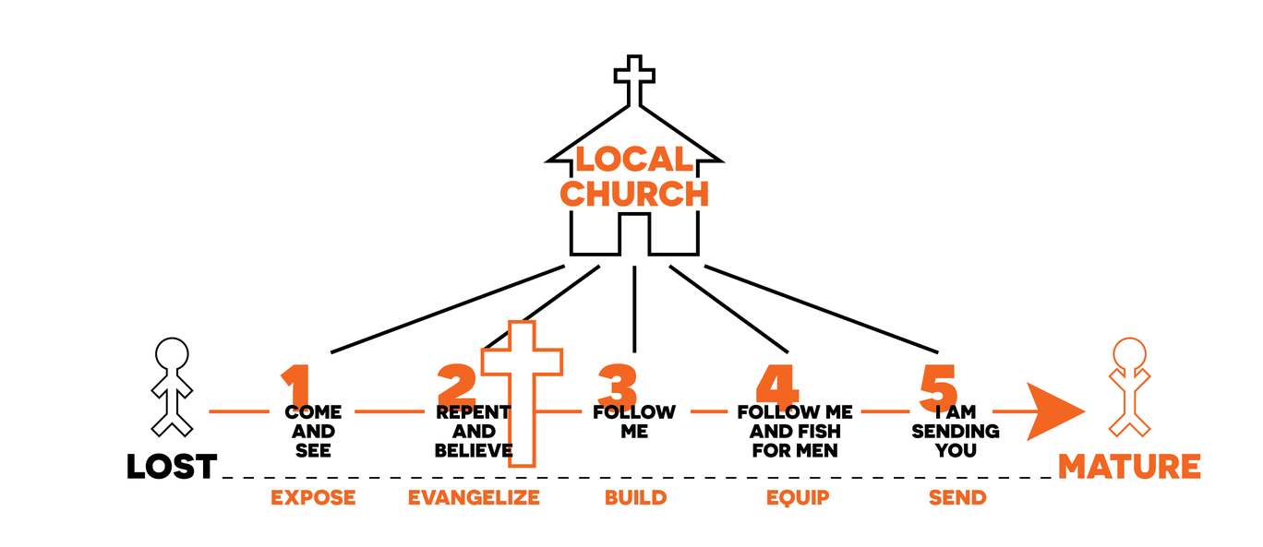

- Going deeper:

  - Write down the three most important issues or questions that you are facing in your ministry right now.

1.

2.

3.

  - What insights or help do you find when you look at these questions through the lens of the Jesus model? Remember the key commands of the great commission – make disciples and look to Jesus.

