Leading Through the Organizational Life-Cycle

Just as a family's needs and dynamics change through different seasons of life, so organizations mature through different stages in their life-cycle, and the style and role of leaders needs to adapt accordingly. Often the most effective type of leadership at the beginning becomes the very thing that hinders further growth later on. A wise leader must change their leadership style to match the current needs of the church or organization. If not, the leader begins to burn out and growth comes to a halt. Fortunately, this organizational life-cycle is predictable. What are these typical stages of development? How can a leader learn to shift “leadership gears” in order to enable continued growth?

Dave Patty has been involved in training youth leaders and leading national and international youth movements in Europe for over 30 years. He serves as the president of Josiah Venture. He is also a founding member of Global Youth Initiative, which mobilizes and equips youth ministry trainers in over 60 countries of the world. Dave is an ordained pastor with a BA in theology and a MA in education. He has also done graduate work in leadership development at Harvard University. For the past 27 years he has lived in the Czech Republic, and he spent the 10 years before that in Germany. Dave is married to Connie and has three grown children, Tyler, Caleb, and Claire.

Four Organizational Life Cycle Theories

- Larry Greiner - 1972

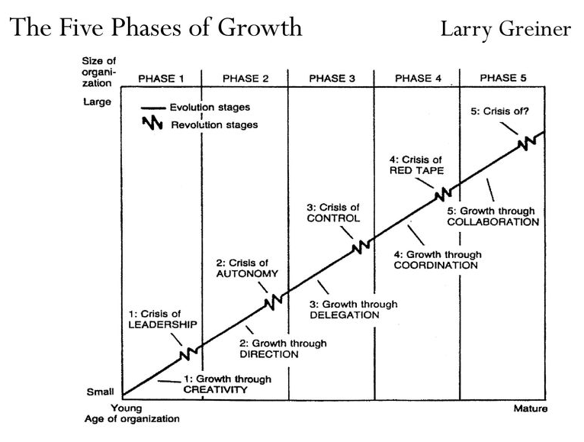

- According to Larry Greiner, there are 5 phases of growth in an organization, each indicated by an evolutionary and subsequently, a revolutionary phase.
- An evolutionary phase, refers to an extended duration of expansion enjoyed by the organization with no significant disruptions. Similarly, a revolutionary phase refers to a period of considerable disturbance within an organization.

- Phase 1: creative expansion → leadership crisis

- Phase 2: directional expansion → autonomy crisis

- Phase 3: expansion through delegation → control crisis

- Phase 4: expansion through coordination → red tape crisis

- Phase 5: expansion through collaboration

- Adizes (1999) organizational life cycle

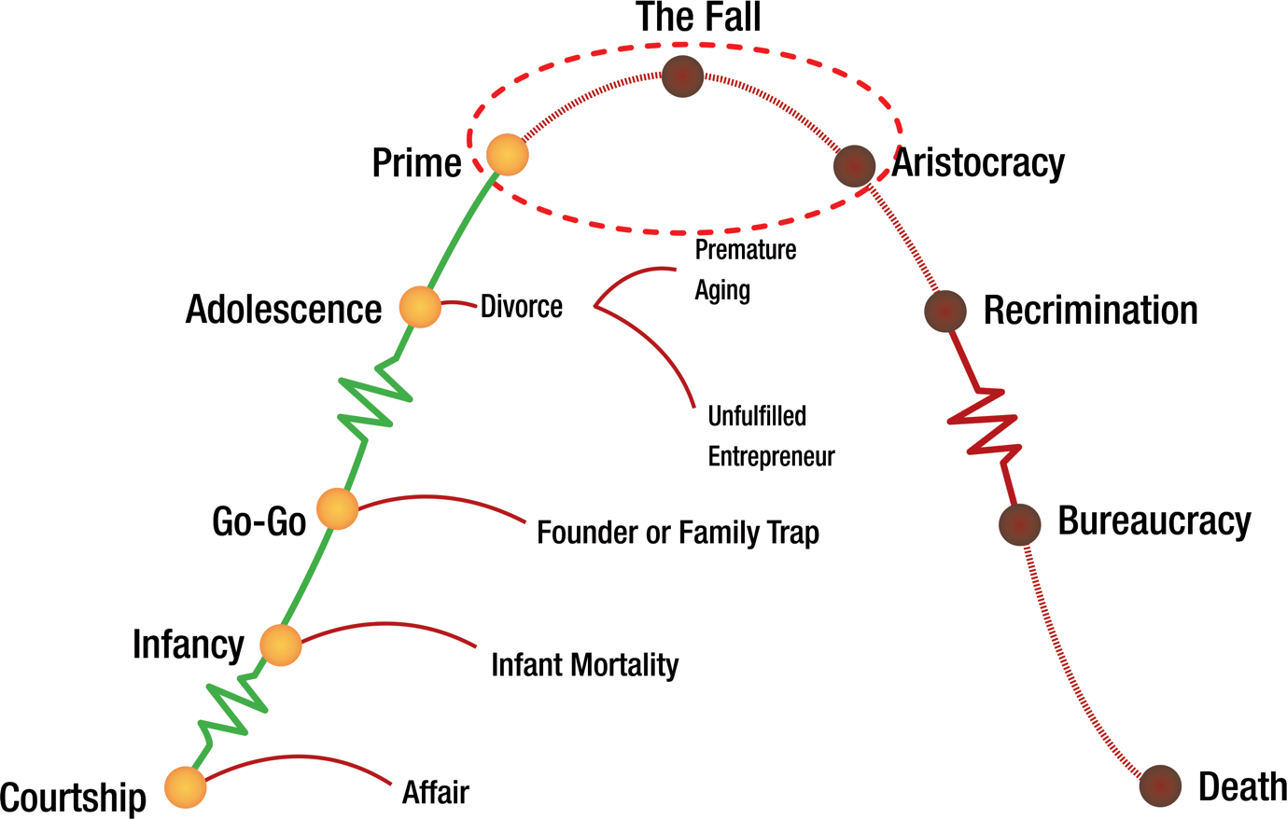

- The model suggests that organizations develop through 10 stages: courtship, infant, go-go, adolescent, prime, mature, aristocratic, early bureaucracy, bureaucracy and death. Progression across stages occurs mainly by overcoming the growth problems of successive stages

- Nonprofit Lifecycles by Susan Kenny Stevens (2001), and The 5 Life Stages of Nonprofit Organizations by Judith Sharken Simon (2001)

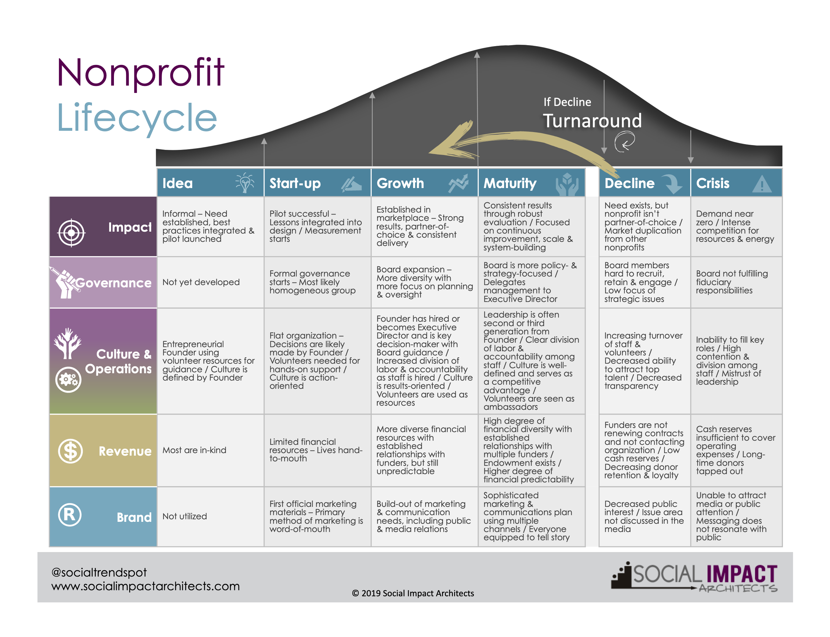

Source - https://nonprofitlifecycles.com/institute/

- Susan Kenny Stevens echoes Greiner’s theory that nonprofits operate and grow within predictable (though not always sequential) lifecycle stages. Where Greiner focuses on the deterministic aspects of life stages, Stevens illuminates its diagnostic value.

- Considering five organizational dimensions – programs, leadership, governance, financial resources, and administrative systems – one can gain an understanding of an organization’s life stage. Once identified, the information can be used as a starting point to build capacity in the most appropriate ways for your nonprofit.

- Five Ministry Phases from the life of Christ – Dann Spader, 1985

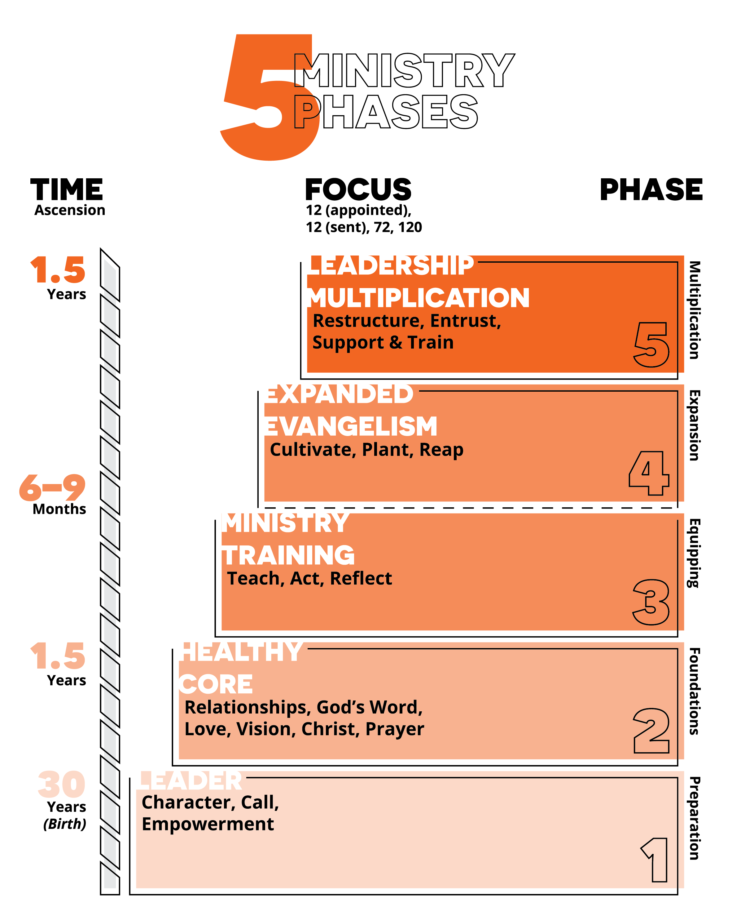
- Spader takes a harmony of the gospels, based on the chronology of Luke, and follows the development of Christ’s ministry over time.

- Phase 1 – Preparation (30 years)
- Priorities – Character, Call, Empowerment

- Phase 2 – Foundations (1 – 1.5 years)

  - Key transition event – Baptism by John

  - Leader shift – from careful preparation to risky action

  - Priorities – Prayer, Relationships, God’s Word, Love, Vision, Christ

  - Much time in homes and in conversation. Only two recorded miracles.

- Phase 3 – Equipping (6 months)

  - Key transition event – calling of first five disciples

  - Leader shift – from making disciples to making disciple makers

  - Priorities – TAR – teach- act – reflect

      - Training in the trenches

      - 6 fishing trips

- Phase 4 – Expansion (same 6 months as above)

- Priorities – CPR (Cultivate, plant, reap)

- Expanding to crowds, new regions, increased disciples

- Broad teaching, many miracles

- Phase 5 – Multiplication
  - Key transition events – naming of the 12, sending of the 12, sending of the 72, releasing the 120 in Acts.
  - Leader shift – from equipping workers to multiplying leaders

  - Priorities – REST – restructure, entrust, support and train

- Final Leader shift – from physical presence to spiritual and emotional support (Go…, I am with you always)

- Application to your organization or ministry

  - What developmental phase or lifecycle are you in right now?

  - Based on that insight, what should be your current priorities?

  - What is the key leadership shift that you need to make to open the way for more growth?

Resources:
Adizes, Ichak. Corporate Life Cycles: How and Why Corporations Grow and Die and What to Do About It. Englewood Cliffs, NJ: Prentice-Hall, 1988.

Bridges, William. Managing Transitions: Making the Most of Change. Reading, MA: Addison-Wesley Publishing Company, 1991.

Collins, Jim. Good to Great and the Social Sectors: Why Business Thinking is Not the Answer. Boulder, CO: Jim Collins, 2005.

Collins, Jim. How the Mighty Fall and Why Some Companies Never Give In. New York, NY: Harper Collins Publishers, 2009.

Connolly, Paul M. Navigating the Organizational Lifecycle: A Capacity-Building Guide for Nonprofit
Leaders. BoardSource, 2006

Simon, Judith Sharken with J. Terence Donovan. The Five Life Stages of Nonprofit Organizations.
Amherst H. Wilder Foundation. Saint Paul, MN: 2001.

Stevens, Susan Kenny. Nonprofit Lifecycles: Stage-Based Wisdom for Nonprofit Capacity. Wayzata, MN: Stagewise Enterprises, Inc, 2008.

Strategy of Christ Ministry – Sonlife, Dann Spader, 1985

Organizational Lifecycles Overview

Stevens’ Non-profit lifecycle stages | Idea | Start up | Growth |  | Maturity | Decline | Turnaround | Terminal
Sonlife ministry phases – Spader | Preparation | Foundation | Equipping | Expansion | Multiplication
Adizes organizational lifecycle | Courtship | Infancy | Adolescence |  | Prime | The Fall  Aristocracy  Recrimination |  | Bureaucracy Death
Greiner phases of organizational growth | Growth through Creativity | Growth through Direction | Growth through Delegation | Growth through Coordination | Growth through Collaboration
Leader shift that takes you into this phase | Moving from current activities to waiting on God and listening to others. Creating space to think, ask, and pray. | Moving from careful preparation to risky, faith-filled action. | Moving from doing to equipping | Moving from incremental (%) to exponential (X) growth | Moving from equipping workers to multiplying leaders | Moving from constant innovation to simply maintaining stability and the status quo | Moving from excuses and explanation to honestly facing reality and taking courageous action | Moving from holding on to the past to releasing resources to others for the future. Shepherding to an honorable end.
Key priorities  - Impact  - Team  - Operations  - Governance  - Revenue  - Communications | Prayer and Fasting.  Experience a clear call.  Understand the need you are trying to meet and the people you are trying to serve.  Develop an initial plan.  Reality test your ideas and strategies. | 1.Develop fruit producing models  2. Build a core team and expand relationships  3. Develop an initial organizational structure  4. Find and engage a mentor or guide  5. Develop a financial model that can sustain and grow  6. Create a clear vision, mission, and identity | 1. Turn best practice insights into “recipes” that can be easily passed on. Learn how to multiply fruit producing models.  2. Free up additional people to serve full time, or to give significantly more energy to the work. Shift more attention equipping them, training “in the trenches”  3. Develop elegant systems and procedures that save energy, finances and leadership time  4. Establish a legal board or a formal group of advisors.  5. Develop monthly sources of income as well as key partners who will give one time to special needs. 6. Develop patterns of regular communication with your team, stakeholders, and partners. | 1. Increase impact by key moves that create exponential growth. Often this comes through new fields, new partnerships and new open doors.  2. Balance the team with a range of gifts so that each can focus on their area of greatest contribution.  3. Scale systems and administration to increase efficacy and keep up with growth.  4. Strengthen the board with a balance of gifted and givers.  5. Develop key relationships with people who have significant financial capacity. Continuously expand the network of small givers, or long-term partners.  6. Communicate vision, stories and inspiration in quality ways that connect and motivate your team and partners. | 1. Multiply impact by releasing leaders and empowering them to carry portions of the ministry and open new territory. REST - Restructure, entrust, support and train  2. Help your leaders build and care for their own teams, while keeping them growing through ongoing input and connect with peers  3. Decentralize many operational responsibilities, retaining only the key parts that multiply and empower the various teams.  4. Assist leaders in developing mentoring relationships and their own groups of advisors  5. Empower others to raise resources including major donor work. Maximize delegated fund raising to ensure ongoing growth.  6. Communicate the big picture to all, but equip other leaders to communicate their zone in compelling and motivating ways. | Recognize you are in this phase and move to regeneration or turnaround. | 1. Carefully evaluate the true impact of your activities by honest conversations with the target audience and stake holders, and evaluation of key “scorecards”  2. Listen carefully to feedback from the team and empathetically make the key decisions designed to move people into the right roles, and move some off of your team.  3. Increase efficiency by pruning unnecessary processes and bureaucracy that has grown over the course of time.  4. Renew the board with people who are gifted in leading change.  5. Make significant adjustment to the budget to channel funds from maintenance of the past to innovation for the future.  6. Overcommunicate to everyone. | 1. Celebrate the impact from the past while recognizing that season has passed. Look for the key investment or leaders that could carry that same impact in the future, if the baton and remaining resources are passed to them.  2. Honor those who have served well, and shepherd them on to the next phase of life and service.  3. Make sure that operations does not consume unnecessary resources that could be given to others.  4. Use the authority of the board to wisely bring the organization to an end.  5. Honor and thank those who have given, and help them direct their funds to others.  6. Communicate celebration and clear closure, along with thanks for all the efforts that have been invested up until this point.
Common  dangers | Relying on your own strength, distraction.  Trusting your intuition and not asking, listening and testing.  Adizes – “Affair” | Not persevering  when tested, extending beyond your energy or financial resources, having no margin for the inevitable setbacks or failures  Adizes – “Infant mortality” | Equipping by cloning rather than empowering, just teaching and not acting and reflecting together, not opening up the structure to give others space and authority to serve, not creating and shepherding teams. not seeking and listening to outside oversight and feedback.  Adizes – “Founder or Family trap” | The founder gets tired and doesn’t have the motivation or energy for the next leg of growth. The founder gets bored and looks for a new “start up” to give back the creative thrill and energy of doing the work themselves.  Adizes – premature aging, unfulfilled entrepreneur | Pride, complacency, protecting roles or protecting the past, insulation from feedback or the real needs of the target audience, a lack of attention to results  Adizes – Aristocracy (insulation and pride), recrimination (blaming others or the environment rather than taking personal responsibility) |  | Lack of honesty, lack of courage, unwillingness to make significant changes, living in the past rather than in the future | Lack of empathy, lack of honor, lack of gratefulness, lack of clear leadership from the board. unwillingness to bring things to a closure and embrace “death” so that others can live.  Unwillingness to be generous while losing ownership and control.

